**How can BU Students help other BU Students get Internships?**

# **Problem**

Located along a crucial artery of Boston, a city renowned for its educational institutions and vibrant economy, Boston University students are increasingly having a hard time finding and securing summer internships, a critical component of their educational and professional development. This problem is multifaceted, stemming from an oversaturated market where the demand from students significantly dominates the supply of suitable internship opportunities. The intense competition is exacerbated by the recent silent recession, which has led many organizations to scale back on creating paid internship roles.

This is causing many students to find themselves navigating a disheartening process, with traditional job boards and career services unable to bridge the gap effectively during these times. This struggle not only hurts students' abilities to gain essential industry experience but also their confidence in their career trajectory.

Additionally, local organizations, unaware of the mutual benefits internships can offer, hesitate to invest in creating new roles. This lack of engagement from potential employers further limits the availability of meaningful internship opportunities, another obstacle for students to gain the hands-on experience and professional connections essential for their career growth. Addressing this issue requires innovative solutions that not only connect students with tailored internship opportunities but also encourage organizations to recognize and harness the value that interns bring to the workplace.

# **Implementable Solutions**

In response to this pressing issue, we propose the development of a platform/app that serves as an “internship broker” specifically tailored for BU students and local Boston organizations. Our solution aims to go beyond traditional job listing services by actively exploring and engaging with local businesses, non-profits, and other entities to uncover and create internship opportunities that have not previously been considered.

By working closely with these organizations, we can identify areas where students can contribute meaningful work, gain practical experience, and ultimately create some value. This initiative not only facilitates a direct connection between students and employers but also encourages companies to invest in the local community and realize the benefits of creating shared value.

The platform will feature a user friendly interface that allows organizations to outline their structure, needs, and capacity for supporting interns. Simultaneously, students can create profiles showcasing their skills, interests, and academic backgrounds. Our matching algorithm will then recommend suitable matches, taking into consideration both the students’ career goals and the organizations’ needs. This approach streamlines the process of securing internships while also ensuring a higher quality fit between students and roles. Additionally, the platform could offer support for both parties to maximize the experience, including guidelines for structuring internships, mentorship programs, and feedback mechanisms to continually improve the service.

By acting as a bridge between BU students and local organizations, our platform aims to unlock untapped potential, create new opportunities for experiential learning, and foster a community of collaboration and innovation. This solution not only addresses the immediate challenge of securing internships but also contributes to a broader ecosystem of shared growth and development within the Boston area.

**Initial data gathering**

The quest for internships during college is a journey fraught with challenges. After conducting interviews with college students the average rating for their current internship search experience was 6/10. The data we gathered from the interviews is summarized as follows:

The competition for limited positions is fierce, leaving many of us feeling overwhelmed and disheartened. The pressure to have relevant work experience weighs heavily, intensifying stress levels with each rejection. Balancing internships alongside academic coursework and other commitments adds another layer of complexity to the already daunting search for opportunities.

Navigating through the intricacies of securing internships reveals a landscape filled with logistical hurdles and administrative complexities. Crafting the perfect resume and cover letter becomes a meticulous art while facing countless applications and interviews feels like navigating a maze. Limited access to networking opportunities compounds the struggle, particularly for students from underprivileged backgrounds or attending colleges with fewer resources.

International students face an even more arduous journey in their pursuit of internships, grappling with additional barriers related to work authorization and cultural adaptation. Visa restrictions and complex immigration policies severely limit their options, often forcing them into unpaid or underpaid positions that may not align with their career aspirations. Cultural differences and language barriers further complicate matters, hindering effective communication and integration into the workplace.

What exacerbates the plight of international students is the glaring lack of adequate support and resources tailored to their unique needs. Many colleges and universities fall short of providing specialized career services, leaving international students feeling marginalized and overlooked. The absence of targeted guidance on visa regulations, cultural competency, and job search strategies only serves to compound their difficulties, perpetuating feelings of isolation and frustration.

Moreover, the rise of online platforms and job boards has made it easier for scammers to prey on unsuspecting students. Fake internship postings, phishing schemes, and identity theft are just a few examples of the risks associated with navigating the digital landscape of internship searches. Students may inadvertently fall victim to these scams, resulting in financial loss, identity theft, or other negative consequences.

Lastly, some students feel insecure about applying to unpaid internships and social work with NGOs, fearing they won't gain valuable learning experiences or recognition for their contributions. They worry that these opportunities may not provide the skills or rewards they seek, leading to uncertainty about their value and relevance in their career development. This insecurity underscores the importance of ensuring that internships and social work placements offer meaningful learning experiences and recognition for students' contributions to their fields.

**Refined problem statement**

The core issue revolves around the myriad challenges that college students face when trying to secure internships, with international students encountering even greater obstacles. The intense competition for limited positions creates a sense of overwhelming pressure and discouragement, amplifying the desperation to gain relevant work experience. Juggling internships alongside academic coursework feels like an impossible balancing act, further complicating the search for opportunities. The daunting task of crafting standout applications and forging professional connections adds to the overwhelming complexity.

For international students, these challenges are magnified by additional barriers such as navigating complex visa regulations and cultural differences. The constant struggle to obtain work authorization and adapt to a new culture creates a sense of alienation and despair, hindering their internship prospects. The absence of tailored support services only deepens the feelings of isolation and frustration, leaving international students feeling marginalized and forgotten in their pursuit of meaningful experiences.

Addressing these challenges requires a heartfelt commitment from educational institutions, employers, and policymakers to ensure that every student, regardless of their background or nationality, is given a fair chance to pursue their career aspirations. It's not just about securing internships; it's about providing a lifeline of hope and opportunity for students who are struggling to find their place in the world.

**Thinking of solution**

In the process of solution ideation, we grappled with two possible avenues for solving the issues we identified for college students searching for internships: an internship-focused agency and a multifaceted app/platform interface for aiding in the internship search.

While we had initially discussed a career agency as a potential solution for the internship disparity we identified through the refining process, we came to the conclusion that this wouldn’t allow us to provide our target audience with an easily accessible, adaptive user interface. Transitioning our solution to an app/ platform would allow students the ability to continue their internship search from anywhere. Further, this switch specifically will be beneficial in allowing students to balance their schoolwork, and extracurricular activities, and receive specialized career development aid.

This solution would be most effective because it addresses each of our users' needs and takes into account many of the problems they identified with traditional methods of conducting searches for internships. The specific functions of the interface were crafted based on the identified needs and feedback of users: provide resume and cover letter advising, mentorship opportunities, identify potential grants for specific unpaid opportunities, and allow organizations to engage directly with prospective student interns.

**Prototyping/Testing**

Our prototyping process involved creating a mock-up of a potential app homepage to show interviewees as well as crafting a list of the services and resources that would be available on the proposed platform. We used online resources to create potential app screens and user interfaces that would be elements of the finalized app. We additionally created screens for a few potential resource pages of the app and provided interviewees with a curated list of the additional functions and attributes of the app. This form of prototyping allowed us to show potential users what the app could potentially look like and what benefits utilizing the app could have on their internship experience.

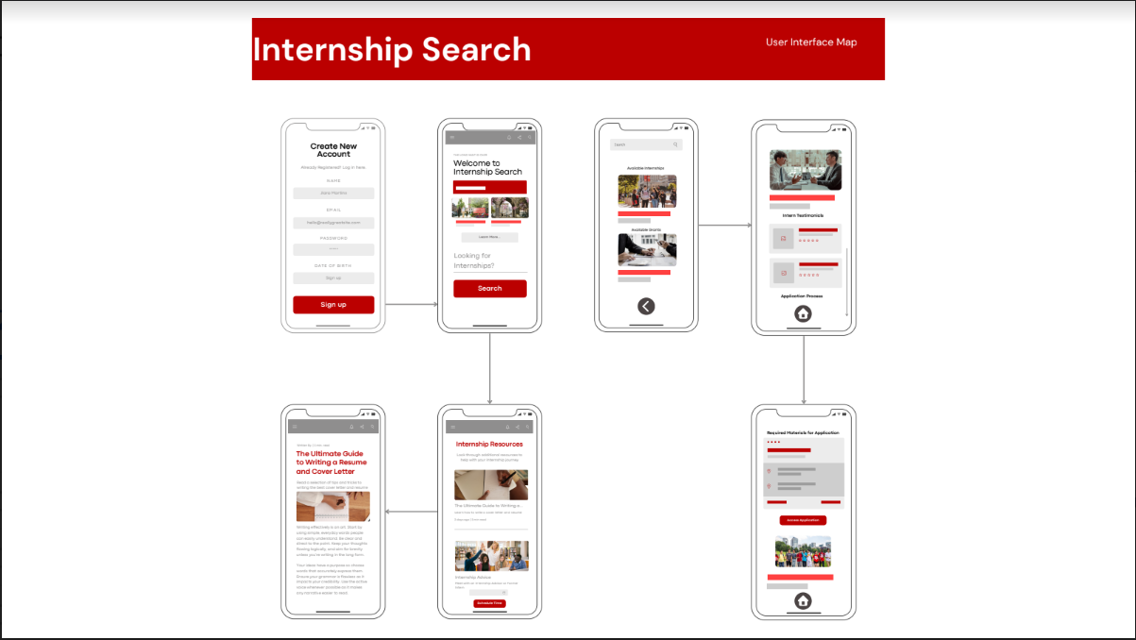

Fig1. Prototype of the mock-up interface

For prototype testing, we offered interviewees to look at the potential design for the app and help us gather information about the app design's current aesthetics and potential functionality. By showing concrete examples of what the app design would be and highlighting the services available through the app, we were able to give potential users a clear description of our proposed product and discern market relevance, app usability and interface, and overall user experience.

This manner of testing allowed us to get feedback on the app's visual appeal, from design elements, color scheme, and typography, as well as user journey and flow when using the proposed app. Although due to time constraints, we were not able to code the full app, having a mock-up of the home page and other app elements helped us to gather feedback on how each student would utilize the app and gave us enough information to identify possible bottlenecks and points of confusion in the user experience.

Potential users stated that they liked the red and white color scheme of the app as it would initially be targeted primarily towards Boston University students. Further, interviewees stated that the proposed resource pages looked like they could be easily navigated and would be adequate to give students the most streamlined user experience. The interviewed users also overwhelmingly said they would like to use the app for their internship search. Many users stated that they believed the app would help alleviate the stress of balancing school work and the internship search through its easy-to-use design; juggling school life and the internship search was one of the pain points we had previously identified in the problem statement. Some did request we have more robust ways for students to speak directly with local businesses.

**Next Steps**

The next steps to practically implement our idea involve further refining the app prototype based on the feedback received during testing. This refinement process should focus on enhancing user experience by incorporating suggested improvements such as facilitating direct communication with local businesses. Additionally, we need to prioritize developing the backend infrastructure to support the app's functionality, including database management for storing user profiles and internship listings. Simultaneously, we should begin recruiting a team of developers, designers, and content creators to collaborate on building the app. Securing funding or investment to support app development and marketing efforts will be crucial for sustaining the project long-term. Establishing partnerships with colleges, universities, and local businesses will also be essential to ensure the app's success and reach a broader audience. Finally, continuous testing and iteration will be necessary throughout the development process to ensure that the app meets the evolving needs of its users and provides an effective solution to the challenges of internship searching for college students, including international students.

**Reflections**

While the mock-up provided valuable insights into the app's aesthetics and functionality, the absence of a fully functional prototype limited our ability to gather comprehensive feedback on user experience and identify potential usability issues. Going forward, investing resources into developing a fully functional prototype would enable more thorough testing and refinement. Despite these challenges, the positive reception from users, particularly regarding the app's visual appeal and potential to alleviate the stress of internship searching, underscores its potential for success. The overwhelming interest expressed by interviewees in utilizing the app for their internship search validates the relevance and necessity of such a solution in addressing the identified challenges faced by college students. Moving forward, incorporating user feedback into iterative design updates and maintaining open channels of communication with stakeholders will be essential for ensuring the app's continued success and effectiveness in supporting students' internship pursuits.

**Appendix**

Interview Questions Asked:

* Main obstacle(s) to finding internships?
* On a scale of 1 to 10, how satisfied are you with your current internship search process?
* What specific improvements or additions do you think would significantly enhance your satisfaction with the process
* Even with the presence of platforms like Handshake and LinkedIn, what problems do you face in your internship search?
* What is your opinion on a paper full of opportunities, alongside the recruiter’s contact and other vital insider information?

Course Material we referred to:

* Don Norman, The Design of Everyday Things Chapter 6 Design Thinking

Team Members:

Anmar Abdi

Sambhav Sancheti

Christina Boye

Taha Moukara